**2 - What is ServiceNow | ServiceNow Administration & Developer Overview**

**Exploring Admin and Developer Roles -** The course is designed to teach both ServiceNow administration and development, starting from the basics and progressing to advanced levels. It covers core admin tasks such as managing users, groups, dashboards, and workflows, and later transitions into development, where participants learn how to build applications, configure workflows, and work with different modules like incident and problem management. The hands-on learning approach helps prepare participants for real-world ServiceNow roles.

**Major Customers -** ServiceNow is used by major companies across various industries, including Netflix, American Express, Airbus, Citibank, and Facebook. These organizations leverage the platform for key functions such as incident management, customer support, and development operations, showing its versatility in different sectors.

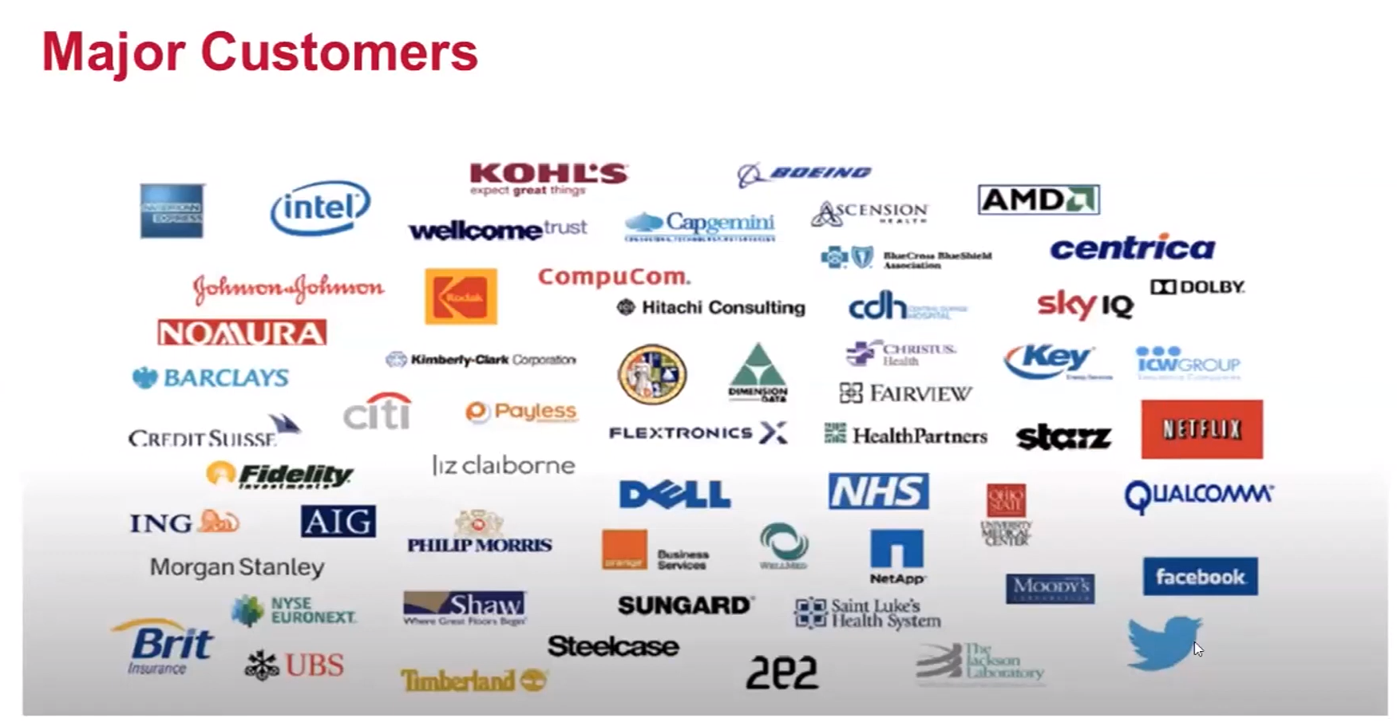

**ServiceNow Growth -** Since its founding in 2004, ServiceNow has experienced tremendous growth, evolving from a simple ticketing tool into a robust, cloud-based platform. It replaced BMC Remedy and now supports IT service management, HR, security, and customer service. Its stock price reflects this growth, rising from $0.36 to around $500.

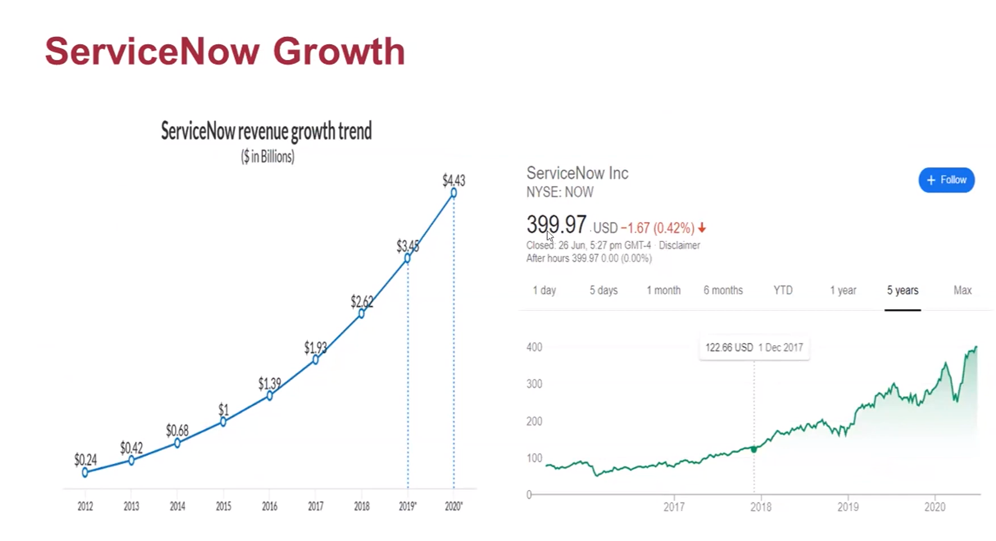

**ServiceNow Architecture** - ServiceNow is a cloud-based platform that doesn’t require software installation. Its architecture is highly modular, supporting various business functions such as IT service management, HR, and security. Users can build applications and automate processes without heavy coding, making it accessible to a wide range of professionals.

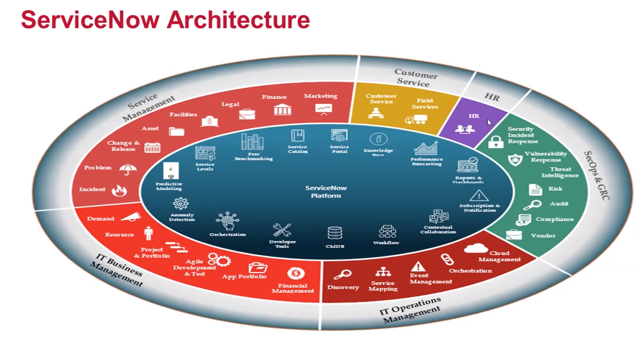

**Who Uses ServiceNow? -** ServiceNow is used by system administrators, developers, business analysts, project managers, and non-technical users in industries like IT, finance, and health care. It supports multiple functions, from IT management to HR and customer service automation.

**What is a Catalog -** The catalog in ServiceNow works like an online store where employees or customers can request products or services. It simplifies request management and improves operational efficiency.

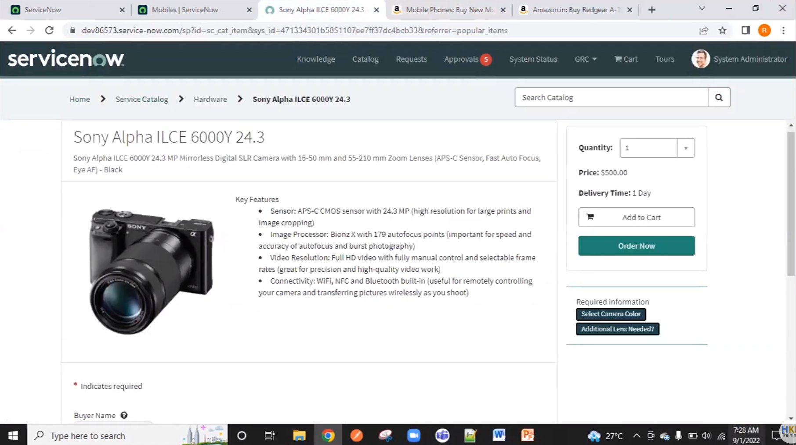

**Dashboard Creation -** ServiceNow enables administrators to create customizable dashboards that provide real-time insights into operational data. These dashboards help monitor key metrics and optimize workflows.

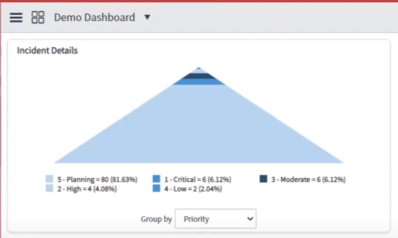

ANANYA CHOUDHARY